Solar protection for plain bearings: new igus material with enhanced UV resistance
New long-lasting high-performance plastic iglidur J UV for lubrication-free solar technology

Today, plain bearings are not only used as simple press-fit bearings but also increasingly in special forms, and in some instances such as in the solar industry, they are exposed to UV radiation for long periods of time. For such special applications, igus has the long-lasting high-performance plastic iglidur J in its product range. The advanced development of this product is iglidur J UV. The new material distinguishes itself with very good UV resistance and benefits from the low coefficients of friction and wear as well as the moisture resistance.

Solar systems as well as other outdoor applications have to function for years often under extreme environmental conditions. This calls for machine components that offer a long service life and prolonged holding times. Furthermore, plain bearings that fulfil their service, for example, in solar tower power plants, parabolic trough power plants or for the mounting of the rotary axis for the panel adjustments, should have the lowest possible costs. For such application scenarios, igus now has an optimised, advanced development of its wear-resistant and durable standard material iglidur J, which is the high-performance plastic iglidur J UV. The new UV-stabilised material is especially suitable for continuous direct sunlight. Like all igus plain bearings, the iglidur J UV plain bearings too, by virtue of their incorporated solid lubricants, are lubrication-free and thus maintenance-free as well as insensitive to dust and dirt. In addition, the long-term mechanical properties of iglidur J UV have been further enhanced. This provides the customer with the ideal material for extremely smooth-running, lubrication-free and long-lasting solar systems.

iglidur J UV defies sun, wind and rain
Due to its corrosion-free properties and good resistance to media, moisture and other environmental influences are no obstacle to the use of iglidur J UV. The tribological properties such as friction and wear of the UV material are comparable to those of the standard material iglidur J. Its low coefficients of friction in dry operation and the extremely low stick-slip tendency are very important for very low speeds, as are common in tracking systems in the solar industry. High speeds of over 1 metre per second are also possible. In both cases, the static friction is very low, whereby the stick-slip tendency is avoided. Initially, the material will be available with and without flange up to a shaft diameter of 20 millimetres. Bearings made of iglidur J UV are available upon request in all previous standard dimensions of iglidur J as well as in individually designed special geometries.

PRESS CONTACT:  Nitin Prakash  Product Manager  iglidur®  igus (India) Private Limited  36/1, Sy. No. 17/3  Euro School Road,  Dodda Nekkundi Industrial Area - 2nd Stage  Mahadevapura Post  Bangalore - 560048  Phone : +91 7760368383  nitin@igus.in  Visit us on www.igus.in | ABOUT IGUS:  igus GmbH is a globally leading manufacturer of energy chain systems and polymer plain bearings. The Cologne-based family business has offices in 35 countries and employs around 3,800 people around the world. In 2017, igus generated a turnover of 690 million euros with motion plastics, plastic components for moving applications. igus operates the largest test laboratories and factories in its sector to offer customers quick turnaround times on innovative products and solutions tailored to their needs.

The terms "igus", "chainflex", "CFRIP", "conprotect", "CTD", "drylin", "dry-tech", "dryspin", "easy chain", "e-chain", "e-chain-systems", "e-ketten", "e-kettensysteme", "e-skin", "flizz", "iglide", "iglidur", "igubal", "manus", "motion plastics", "pikchain", "readychain", "readycable", "speedigus", "triflex", "plastics for longer life", "robolink", and "xiros" are protected by trademark laws in the Federal Republic of Germany and internationally, where applicable.

Caption:
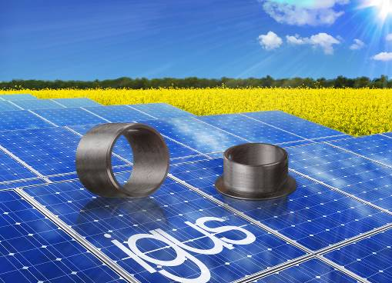
Picture PM3818-1
Ideally suited for solar technology: the new lubrication-free iglidur J UV material with enhanced UV resistance. (Source: igus GmbH)

