Head-to-Head Duel: Tribo-Filament Convincing in Test compared to Injection Molding Quality

Tests confirm abrasion resistance of tribo-filament compared to standard filaments and injection molding

Where do tribological filaments stand in comparison with standard 3D print materials? And do printed parts made of high-performance plastics actually have a lower abrasion resistance than injection-molded components? Now the motion plastic specialist igus has tracked down these questions in their test laboratory. One result was surprising.

With high-performance plastics and additive manufacturing, two modern technologies which combined promise maximum freedom in construction and high abrasion resistance meet. In the igus test laboratory, tribological filaments of iglidur material J260 went up against conventional 3D print filaments (ABS) and injection-molded parts of the same igus material. Intensive linear and rotating test runs were carried out and evaluated in the in-house test laboratory on hardened, ground shafts of both steel and stainless steel over a period of several months. Because additive manufacturing with lubricant- and maintenance-free high-performance plastics is still a comparatively young field, the material experts at igus GmbH encountered an open-ended experiment.

Tribo-filament comes out ahead of ABS material
The result was surprising. It was clear that in both the linear and rotating tests, the abrasion resistance of bearings printed with tribological filament were comparable to the classical injection-molded components, even on both shafts. Thus where abrasion resistance is concerned, the printed components are almost on a par with the injection-molded components. Once again, the tests also clearly demonstrated that in comparison with conventional 3D print materials, the coefficients of friction for tribological filament are especially low. Thus in experiments pitting ABS against tribological filament, the rotating test on the stainless steel shaft even resulted in complete failure of the ABS part, while friction loss for tribological filament was still low. With these actual tests, the testers could demonstrate yet again how motion plastics play out their strengths in movement, even in 3D print. This is why it is possible for printed parts such as bearings or worm gears to be directly installed and used across industries.

Additive manufacturing as another step
For igus, additive manufacturing is one more step to give the design engineer the greatest possible freedom in construction with lubricant- and maintenance-free plastics. The motion plastics specialist igus already introduced the world's first tribological filament for 3D printers last year, and has now expanded the series to a total of four materials. Since the Hannover Messe, igus has also offered a 3D print service. Customers can turn to igus with their 3D data and have their parts printed quickly and without complications. Delivery times for printed parts depend primarily on the complexity of the components; still, here too the goal is delivery within 24 hours.

Captions:

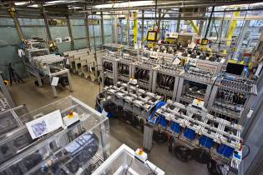
Image PM4015-D-1
igus tests the abrasion resistance of 3D print filament iglidur J260 in comparison with ABS and injection-molded parts in their test laboratory.
(Source: igus GmbH)
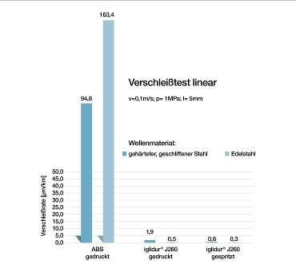
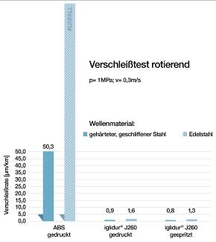

Image PM4015-D-2a & -2b
Result of the test marathon: Here, the low abrasion rate of the tribological filament iglidur J260 comes out ahead in linear and rotational movement. (Source: igus GmbH)

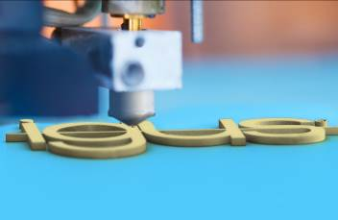
Image PM4015-D-3
With a selection of four tribological filaments and the 3D print service, igus offers customers the possibility to print maintenance and lubrication free special parts and small series. (Source: igus GmbH)

PRESS CONTACT:  Oliver Cyrus  Head of Media and Advertising  igus® GmbH  Spicher Strasse 1a  51147 Cologne  Tel. 0 22 03 / 96 49-459  Fax +49 22 03 / 96 49-631  ocyrus@igus.de  www.igus.de/de/presse | ABOUT IGUS:  igus GmbH is a globally leading manufacturer of energy chain systems and polymer plain bearings. The Cologne-based family business has offices in 36 countries and employs around 2,700 people around the world. In 2014, igus generated a turnover of 469 million euros with motion plastics, plastic components for moving applications. igus operates the largest test laboratories and factories in its sector to offer customers quick turnaround times on innovative products and solutions tailored to their needs.

The terms ‘igus, e-ketten, e-kettensysteme, chainflex, readycable, easychain, e-chain, e-chainsystems, energy chain, energy chain system, flizz, readychain, robolink, pikchain, triflex, twisterchain, invis, drylin, iglidur, igubal, xiros, xirodur, plastics for longer life, CFRIP, dryspin, manus and vector’ are protected by trademark laws in the Federal Republic of Germany and internationally, where applicable.

